**Technical Report Analysis for VolgaMotors Insight 2024**

**1. Introduction**

This technical report presents a data-driven analysis of the Russian used car market in 2024, focusing on vehicle specifications, performance characteristics, and market sales trends. The goal is to uncover what car features such as brand, fuel type, age, and transmission, drive pricing and demand across Russia.

VolgaMotors commissioned this project to refine their inventory strategy, enhance marketing campaigns, and optimize sourcing decisions using insights from over 42,000 vehicle listings.

**2. Story of the Data**

The dataset contains detailed records of used car listings in Russia, including:

**Independent Variables:**

* Car brand
* Car model
* Car city
* Fuel type
* Transmission type
* Drive type
* Country of origin
* Engine capacity
* Engine horsepower (HP)
* Car age

**Dependent Variables:**

* Car price
* Car mileage

These variables help identify which combinations of features are linked to higher sales revenue and resale value.

**3. Pre-Analysis & Key Questions**

Initial data exploration aimed to answer the following:

* Which brands and models sold the most in 2024?
* What fuel types and transmissions are most preferred?
* What engine capacity and HP ranges are linked with high resale values?
* Are younger or older cars selling better?
* What role do cities play in car turnover?
* How do price and mileage relate to each other across vehicle segments?

**4. In-Analysis Observations**

**Top Performing Brands (by Sales Volume):**

* **Toyota** – ₽15 billion
* **KIA** – ₽6 billion
* **BMW** – ₽5 billion
* **Mercedes-Benz** – ₽5 billion
* **Hyundai** – ₽4 billion

**Transmission Trends:**

* Automatic transmission vehicles dominate the market.
* Manual and robotic systems account for a minimal share.

**Fuel Type Preference:**

* Gasoline-powered vehicles are the most sold.
* Hybrids and diesels are niche, except within Toyota’s lineup.

**Model Highlights:**

* **Toyota**: Land Cruiser, Camry, Prado
* **BMW**: X5, 5-Series
* **KIA**: Rio, Sportage
* **Hyundai**: Solaris, Creta
* **Mercedes**: E-Class, S-Class

**Age and Mileage Patterns:**

* Most sold vehicles are 2–15 years old.
* Average mileage: 110,000–170,000 km.

**5. In-Analysis Recommendations**

**Inventory Focus:**

* Stock gasoline-fueled, automatic transmission cars from the top five brands.
* Prioritize popular models like Toyota Land Cruiser and BMW X5.

**Procurement Strategy:**

* Focus on vehicles under 10 years old with mileage under 150,000 km.
* Optimal engine range: 1.8L–2.7L and 150–250 HP.

**Marketing Strategy:**

* Promote cars based on fuel economy, engine durability, and automatic transmissions.
* Run city-based campaigns in high-demand areas like Astrakhan.

**Data-Driven Tools:**

* Build predictive pricing models using age, mileage, and engine specifications.
* Train sales teams on model-level performance insights.

**6. Visualization**

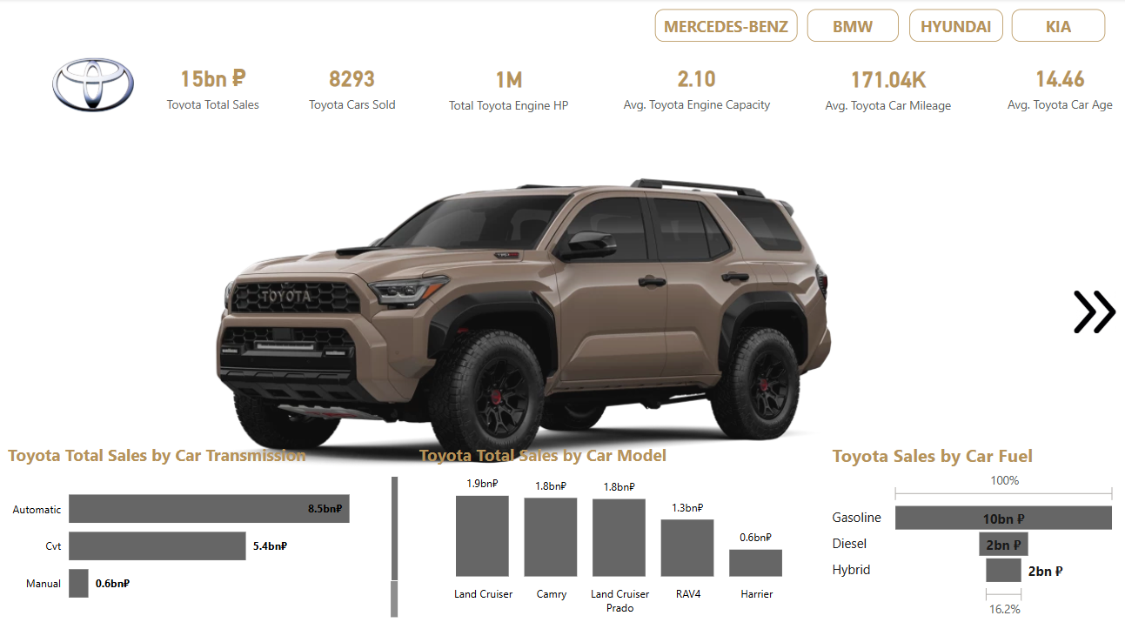

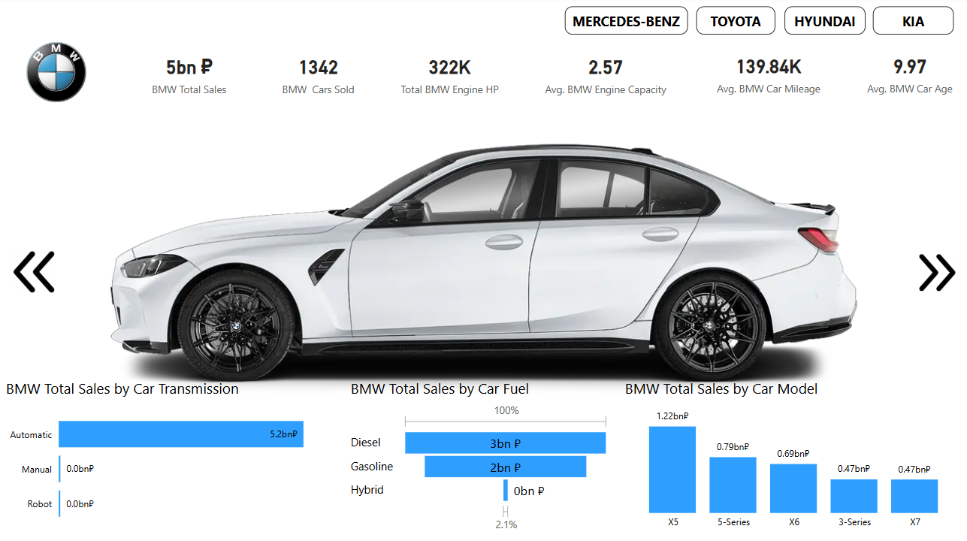

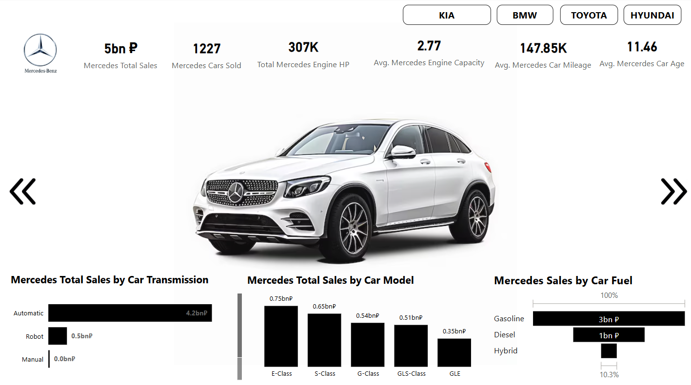

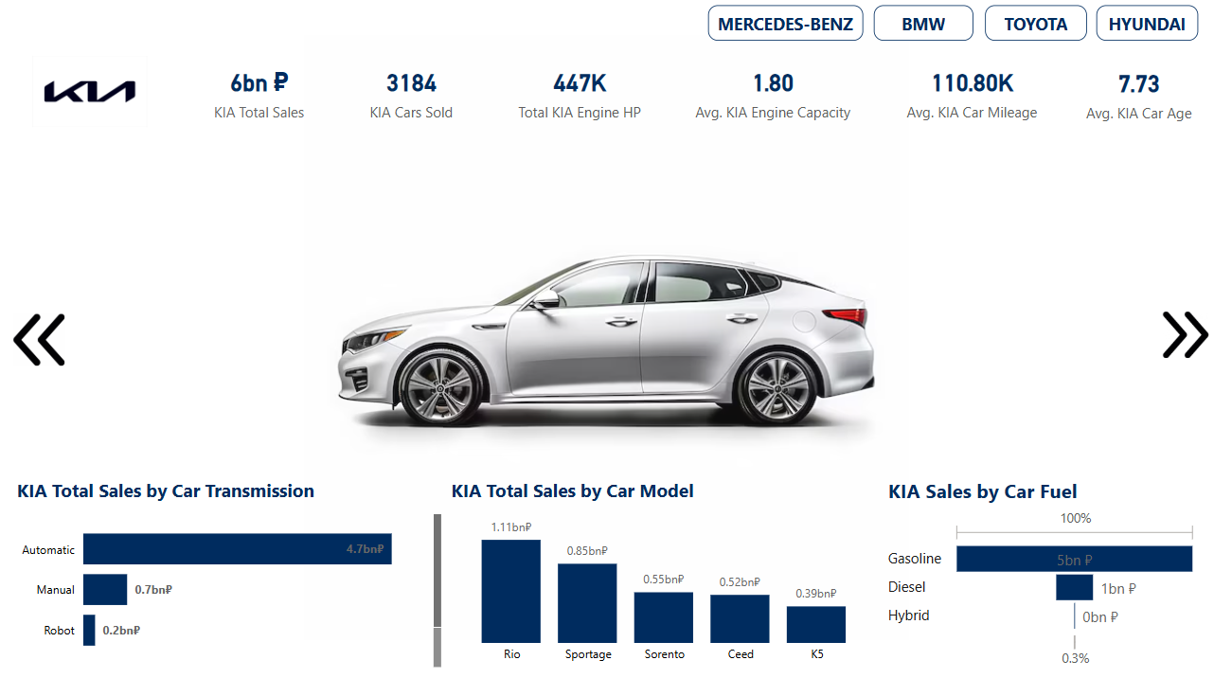

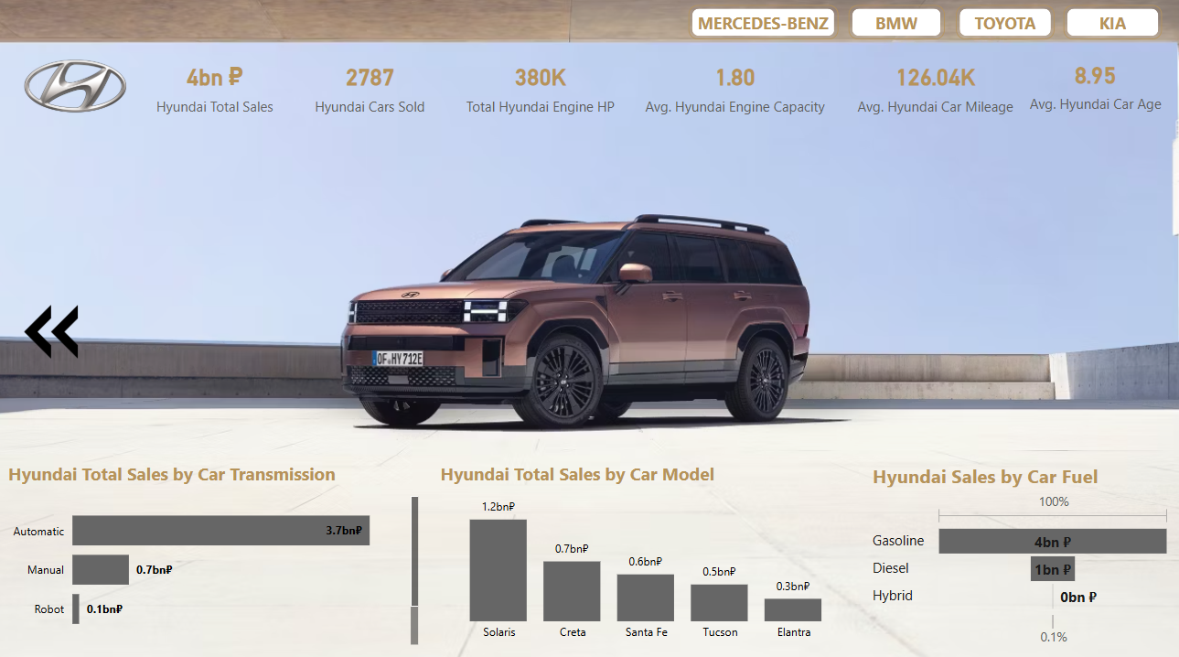

**7. Final Observation**

2024 trends reveal that the Russian used car market is centered on reliability and performance. Gasoline engines, automatic transmissions, and well-known brands led the charts. Car age and mileage were influential, but brand trust and vehicle condition had greater weight in driving price.

Toyota remains the top brand, with others like BMW, Mercedes, KIA, and Hyundai trailing closely. Sales tend to cluster around vehicles with moderate engine specs, manageable mileage, and less than a decade of use.

**8. Final Recommendation**

* Prioritize gasoline-powered, automatic cars from Toyota, BMW, Mercedes, KIA, and Hyundai.
* Source vehicles with low mileage and under 10 years of age.
* Optimize inventory using predictive pricing models based on mileage, age, and engine specs.
* Run focused marketing campaigns on best-selling models emphasizing reliability.
* Establish dealership partnerships in regions with high car sales (e.g., Astrakhan).
* Train sales staff to understand and highlight features that influence price and buyer decisions.

By implementing these insights, VolgaMotors can maximize profitability, enhance brand trust, and lead the Russian used car market in 2025